enviaM accelerates the intraday trading process with ProCom solution
Speed up power trading with ITA
Aachen, October 31, 2019 – envia Mitteldeutsche Energie AG (enviaM), headquartered in Chemnitz, markets the flexibility of its own power plants and customer plants in short-term trading on the EPEX SPOT and Nord Pool power exchanges. From now on, enviaM receives support by ITA, an intraday trading solution from ProCom. It enables the leading regional energy service provider in East Germany to trade quantities automatically and implement trading strategies more quickly.
ITA consists of an intraday market monitor, a portfolio manager and a trading assistant. The market monitor provides an overview of the current market; intraday order books, products and price developments can be tracked in real-time. The portfolio manager provides transparency on the production status, schedules and positions and supports rolling optimization. The trading assistant is the interface to the power exchanges EPEX SPOT and Nord Pool and simplifies processes such as bidding. ITA also offers the option of defining trading strategies and automatically creating bids based on them.
“Compared to 'manual' trading, intraday trading with ITA is much easier”, says enviaM project manager Daniel Panitz. The transparent software interface and workflow features also contribute to this. Among other things, profiled orders requested by trading partners can be priced faster with ITA and corresponding offers can be sent. Smaller transactions can also be automatized. Panitz explains where auto-trading makes economic sense: “One of our customers offers primary control power with its power storage. In order to be prepared for the next request, the charge state must be optimized. Only small quantities need to be traded, but this may be very spontaneous.” With the ITA automatisms, corresponding orders can be placed shortly before gate closure.
Currently, enviaM’s traders are gaining their first experience with ITA and are adjusting the system to their needs. Among other things, they configure plausibility checks and define trading strategies so that (partially) automated processes can be handled as securely as possible. “At the turn of the year, we want to complete the commissioning and automate the first trading transactions”, says the project manager.
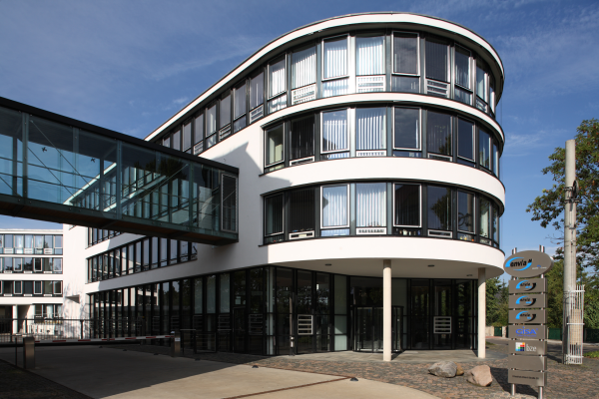
The Markkleeberg location of enviaM (photo credit: enviaM)
You can find the printable photo here.
Press and public relations:

ProCom GmbH
Anke Dieterich
Luisenstrasse 41
52070 Aachen
Germany
Tel. +49 241 51804-105
Fax +49 241 51804-30
Anke.Dieterich@procom.de
www.procom.eu
Press’n’Relations II GmbH
Ralf Dunker
Graefstrasse 66
81241 Munich
Germany
Tel. +49 89 5404722-11
Fax +49 89 5404722-29
du@press-n-relations.de
www.press-n-relations.com

If you publish this material, please provide us with two specimen copies.

About ProCom
ProCom provides customized and highly innovative software solutions for the energy industry and the automation technology for more than 40 years. The energy business unit offers consulting on all matters relating to the core value creation chains of energy companies, thus covering the entire spectrum from generation and storage through trading to distribution. With their excellent knowledge of business processes, data flows and IT as well as individual consulting, ProCom experts provide support for the implementation of strategic objectives through to operations.
Energy portfolios covering all timelines and markets are managed in an optimum manner using IT solutions, forecasts and market information services. The software can be flexibly integrated into almost any IT structure. More than 150 customers throughout the energy industry’s value creation chain benefit from ProCom solutions, which make energy portfolios and processes more efficient and transparent. IT solutions from ProCom can be your means to leveraging value by processing of data flows and turning them into understandable information. This identifies and reveals potentials. Even in extremely complex situations, you keep an overview, remain flexible and have the capacity to act. At its headquarter in Aachen and locations in Cologne, Berlin, as well as Ningbo, China, the family business has more than 120 employees from twelve countries and pursues a clear strategy of growth and internationalization.
www.procom-energy.de

