Interview with BoFiT user Martin Germann, Head of Portfolio Management at Stadtwerke Saarbrücken GmbH
“Digitalization Creates Twice the Benefits”
Aachen, Germany, 18 June 2019 – Martin Germann, Head of Portfolio Management at Stadtwerke Saarbrücken GmbH, sees vast opportunities in digitalization – both for the optimization of internal processes and to establish new lines of business. It took modern computing to make a new business model possible: a differential energy forecast solution developed by the company from Saarbrücken for distribution network operators. In the interview, Germann explains how this service came about, how it was implemented, and what the team is expecting from further digitalization.

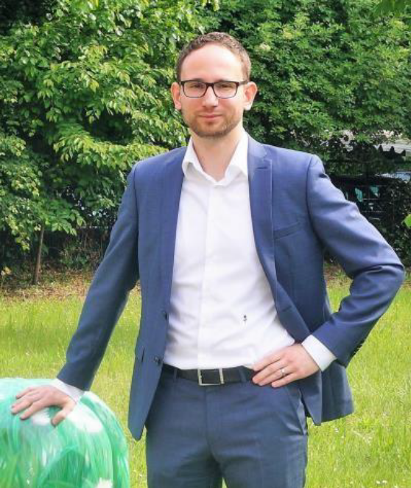
Martin Germann, Head of Portfolio Management at Stadtwerke Saarbrücken GmbH (photo: Stadtwerke Saarbrücken GmbH)
Image download in our Media Database

Mr Germann, is digitalization an opportunity or a risk for Stadtwerke Saarbrücken?
Germann: We see it primarily as an opportunity. Our previous digitalization projects have clearly moved us forward. One example is the operational planning for power plants, where many different parameters have to be taken into account. To achieve maximum profit margins, you have to create transparency not only in terms of the technical limitations, but also with respect to the market. For example, the fuel and market prices must be monitored at all times, contracts and plant restrictions must be taken into account and the usage of plants must be coordinated in advance. Without high-performance processes and software, it would be impossible to handle all of these aspects in a dynamic market environment.
What solutions do you use?
Germann: An important component of our solution landscape is the optimization and forecasting software BoFiT from ProCom. These systems work in an integrated manner, so that our processes can be mapped very efficiently. The systems provide us with the information necessary to make operational decisions in terms of the plants and help us make the most of the flexibility we have.
Speaking of making the most of flexibility: can you give us an example?
Germann: Our plant park includes multiple cogeneration units (CHPs) of the two-megawatt class and an electric boiler, but the ultimate showpiece is the gas and steam plant of an industrial customer, for whom we handle the operational planning of the plant as a service. This plant’s flexibility comprises the ability to make excess quantities of current beyond the intrinsic electricity production available to the market. The associated heat accumulator plays an important role, as it facilitates the decoupling of electricity and heat production and thus enables us to allocate heat to our customers as needed. This gives us the flexibility to produce current at times when profit margins are high on the market. And we achieve this with operational planning using BoFiT Optimization as well as prognostics with BoFiT Forecast.
What is the connection between operational optimization and the differential energy forecast (*) that you offer to distribution network operators as a service?
Germann: The mathematical solutions offered by BoFiT permit many different applications. In terms of our in-house services, we took a look at the differential time series and noticed that our costs for balancing energy were high. Then we requested the data from the responsible department and established a model in BoFiT Forecast, on the basis of which we were able to create a day-ahead timetable for the differential time series.
The financial gains we had through the reduction of balancing energy motivated us to use this process for the Group’s differential energy forecast. Our distribution network operator was thus our first customer. Subsequently, we further optimized the method with BoFiT and presented our solution to other municipal utility companies. The feedback was very positive, as we can offer our customers added value of about 1.5-2 euros per standard load profile metering point annually.
How does it all add up for you and your customers?
Germann: It’s a true win-win situation. We measure success based on the status quo of the customer’s differential time series management. We are only paid for our services if we generate demonstrable added value, which we have achieved every time thus far. So our customers benefit from low balancing costs and not having to buy their own prognostic tool or programming one, and not having to dedicate personnel to such an undertaking.
Speaking of programming: How complex was it to adapt BoFiT to differential energy forecasting, since this is an entirely different process?
Germann: It does take a certain level of know-how to work with BoFiT to be able to adapt it to new tasks. We decided very early on to train some employees to become BoFiT experts. ProCom offers corresponding basic training, which was tailored to our needs. So we were in a position to try new things in the system and expand our range of solutions at an early stage. This comes with a wide range of possibilities, such as the forecasting methods offered by BoFiT.
Will you develop further IT services?
Germann: Yes. The success we’ve had with the differential energy forecasting service has encouraged us to do so. What we are currently looking at are issues related to the Smart Meter and Smart Grid. We see great potential here. If the points of consumption and the network are smart, we will be able to provide more transparency in the network by efficiently processing this bulk data. This has significant advantages for suppliers and network operators, both in terms of controlling and energy demand management. We think this is the perfect angle for us to further apply our digitalisation know-how.
*) see also our press release
Press and Public Relations Offices:

ProCom GmbH
Anke Dieterich
Luisenstrasse 41
52070 Aachen, Germany
Tel. +49 241 51804-105
Fax +49 241 51804-30
Anke.Dieterich@procom.de
www.procom.eu
Press’n’Relations II GmbH
Ralf Dunker
Graefstrasse 66
81241 Munich, Germany
Tel. +49 89 5404722-11
Fax +49 89 5404722-29
du@press-n-relations.de
www.press-n-relations.de

Upon publication, we request two sample copies.
About ProCom GmbH
ProCom provides customized and highly innovative software solutions for the energy industry and the automation technology for more than 40 years. The energy business unit offers consulting on all matters relating to the core value creation chains of energy companies, thus covering the entire spectrum from generation and storage through trading to distribution. With their excellent knowledge of business processes, data flows and IT as well as individual consulting, ProCom experts provide support for the implementation of strategic objectives through to operations.
Energy portfolios covering all timelines and markets are managed in an optimum manner using IT solutions, forecasts and market information services. The software can be flexibly integrated into almost any IT structure. More than 150 customers throughout the energy industry’s value creation chain benefit from ProCom solutions, which make energy portfolios and processes more efficient and transparent. IT solutions from ProCom can be your means to leveraging value by processing of data flows and turning them into understandable information. This identifies and reveals potentials. Even in extremely complex situations, you keep an overview, remain flexible and have the capacity to act. At its headquarter in Aachen and locations in Cologne, Berlin, as well as Ningbo, China, the family business has more than 120 employees from twelve countries and pursues a clear strategy of growth and internationalization.
www.procom-energy.de

